# **Easy Step guide for the TAP supplier platform** Registration

[**https://tap.tcsapps.com/tap2/#/bc-supplier-registration**](https://tap.tcsapps.com/tap2/#/bc-supplier-registration)  
Go through the registration process and enter the OTP when requested (you will be asked to enter a code at least twice).  
  
   
  
Your email will come from `tapapp.service’ and be titled; **British Council MyProcurement Supplier Registration OTP**.

**  
  
  
  
  
Return to home-screen and enter OTP code.  
  
  
  
  
 **Registration email**   
Within your Welcome email, this will outline your Username, one-time password and the URL for y***ou to log in.***

***TIP:*** *The OTP process is quite strict, so please have your code ready before you begin. Enter it carefully in one go, as the system does not allow corrections or re-entry without restarting the process.*Once OTP added, and you log in for the first time – you will be asked which **Language** and then view the **Privacy Notice** (Accept and Proceed) and then a pop up to **update password.**

**The main (home) screen**

  
  
  
  
  
  
On **left-hand side** of the screen – click the following:

Click on **Source-to-Pay** (you will come to a screen called **My Event)**

Again, on **left-hand side** click on **Public Notices**:

Opportunities will be displayed in ascending order, so if you do not see the one you are interested in at the top, then search:

Once you find the interested opportunity, click on the title.

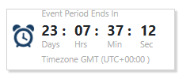**Event participation**

This is where you will find information regarding the project, a sample of the Terms & Conditions (which may well be a sample contract) and the Request for Proposal (RFP). When clicked, these documents will be downloaded.  
  
Once reviewed and you wish to proceed, then click on the confirmation that you have read the T&Cs (which is the RFP), then **click the button** and **Confirm Participation** (you can also **Decline** at this point)

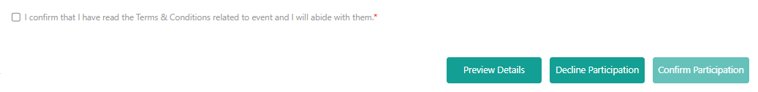

Once you have confirmed participation, then Questionnaire, Event Collaboration and Clarifications will become visible.

**Questionnaire**  
  
 **Within this section is where you will have access to downloading the** Supplier Response document, Pricing Approach document and any other related documents.  
  
There is no need to complete the text box on the platform at this stage, as the supplier response document is downloadable and can be completed offline.

Once your documents have been completed (offline), then you should **upload them back on to the platform,** either by clicking Upload Template or clicking on the paper clip.

Or Once uploaded your documents, remember to click **Save  
  
Event Collaboration**



by clicking the New Message button.

**Clarifications**



This is where **answers to clarifying questions** will be added (any question, from any supplier – will be visible for all to see).

**Questions**Any questions, please contact your British Council contact direct.